COMAPS – Racial Discrimination Study

Prof. Anol Bhattacherjee

Rushikesh Maheshwari

Pragati Shukla

**What is COMPAS? What’s it’s usage?**

COMPAS, which stands for - **C**orrectional **O**ffender **M**anagement **P**rofiling for Alternative **S**anctions is one of the Actuarial Risk Assessment Instrument (ARAI’s) developed by Northpointe Inc. which is used widely in the States to deliver judgment about pre-trials releases of defendants based on certain risk-assessment and corresponding scores. It is being widely used in the United States including states like California, Wisconsin, Florida etc.

When most defendants are booked in jail, they respond to a COMPAS questionnaire. Their answers are fed into the COMPAS software to generate several scores including predictions of “Risk of Recidivism” and “Risk of Violent Recidivism”. Based on the Risk score generated by COMPAS for recidivism (re-offence after release), defendants are categorized into ‘Low’, ‘Medium’, or ‘High’ risk categories. The questions in the COMPAS screening are regarding their criminal history, family background, demographic information etc. (a sample questionnaire is in the Box folder)

**Racial Bias and COMAPS**

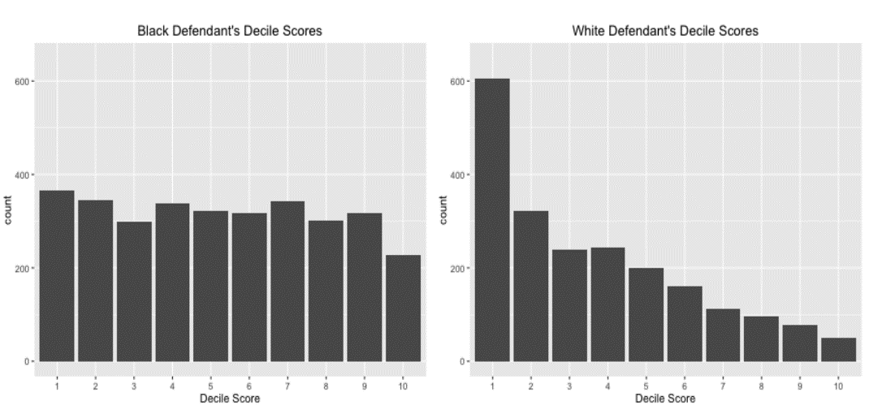ProPublic, an American non-profit newsroom based out of NewYork, presented a study in May 2016 and claimed that COMPAS generated ‘Risk Scores’ are biased against African-American race group. For this study they looked at more than 10,000 criminal defendants in Broward County, Florida, and compared their predicted recidivism rates with the rate that actually occurred over a two-year period. To do so, they also collected data about public incarceration from the ‘Florida Department of Corrections’. By joining these two data sets with a defendant’s first name, last name and Date of birth ProPublica assess about 11000 records.

With their study, ProPublica claimed that COMPAS is racial biased and delivers high risk scores for recidivism in case of African-American people compared to other races.

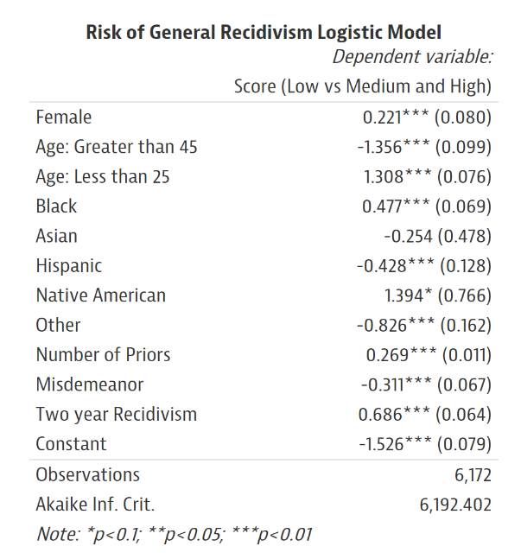With ProPublica’s Analysis, some of the results stated were as below:

1. most predictive factor of a higher risk score was age
2. Defendants younger than 25 years old were 2.5 times as likely to get a higher score than middle aged offenders
3. Black defendants were 45 percent more likely to get a higher score than whites (Caucasian)
4. female defendants were 19.4 percent more likely to get a higher score than men

**Criticism on ProPublic’a Analysis**

After ProPublica had published their analysis, many researchers Data-geeks started replicating their analysis and extended it in their own ways. However couple of articles below points out how ProPublica’s analysis lacks data quality and how they have induced sampling bias.

1. *ProPublica’s COMPAS Data Revisited* – Matias Barenstien - Economist – Federal Trade Comission <https://arxiv.org/pdf/1906.04711.pdf>
2. *False Positives, False Negatives, and False Analyses: A Rejoinder to “Machine Bias: There’s Software Used Across the Country to Predict Future Criminals. And It’s Biased Against Blacks.” – Anthony W. Flores - California State University, Bakersfield   
   Kristin Bechtel - Crime and Justice Institute at CRJ   
   Christopher T. Lowenkamp - Administrative Office of the United States Courts, Probation and Pretrial Services Office* <https://www.uscourts.gov/federal-probation-journal/2016/09/false-positives-false-negatives-and-false-analyses-rejoinder>

The first article by Maritas Barenstien published recent;y (8th July 2019) shows how ProPublica (unknowingly) made a data processing error and included about 1000 more recidivist in the data set as per their time frame of data collection and analysis which nothing but inflated what all results they generated about racial bias by about 24%

The second article talks about how ProPublica has failed to test the bias as per standard and used faulty statistical references and benchmarks to produce the result. (need to read in detail)

NorthPointe Ince. The company who developed COMPAS studied Propublica’s analysis and made some allegation and suggested how propublic’s analysis was wrong:

Specifics are mentioned here: <https://www.propublica.org/article/technical-response-to-northpointe>

***“***[***Northpointe allegation***](https://www.documentcloud.org/documents/2998391-ProPublica-Commentary-Final-070616.html#document/p32/a311057)***:***

*The reverse logistic regression models are misspecified. And the relative risk ratios from the reverse regressions are miscalculated and misinterpreted.*

[***ProPublica Response***](https://www.documentcloud.org/documents/2998391-ProPublica-Commentary-Final-070616.html#document/p32/a311057)***:***

*Our logistic model wasn’t trying to predict who would recidivate. We were trying to identify a possible relationship between race and receiving a high score when controlling for other variables like age, gender and criminal history. We found that*[*black defendants have greater odds*](https://github.com/propublica/compas-analysis/blob/master/Cox%20with%20interaction%20term%20and%20independent%20variables.ipynb#logistic)*of getting a high score that cannot be explained by these other factors. Then we even controlled for future recidivism, and still found that the racial gap couldn’t be explained.”*

**Our Analysis so Far:**

Based on all these articles in support and against ProPublica’s analysis, We performed following steps to understand the underlying data and methodologies better.

1. Understanding US Crime and Judicial proceedings:

To best of our knowledge as looked up from internet and US court website below are the steps involved in a typical Federal Criminal Process. We were trying to understand how and when a COMPAS screening assessment would take place for a defendant.

1. Investigation
2. Charging
3. Initial Hearing/Arraignment
4. Discovery
5. Plea Bargaining
6. Preliminary Hearing
7. **COMPAS Screening Assessment 🡪 Additional Intermediate step**
8. Pre-Trial Motions
9. Trial
10. Post-Trial Motions
11. Sentencing
12. Appeal
13. Understanding the Data

As Mentioned before ProPublica had collected this data in raw format by a public records request and then pre-processed data for each defendant such that we have their offence information as well as the COMPAS fields and risk scores. They created a SQLite copy of this db.

* 1. We had this DB loaded in R and extracted 5 .csv files from where the data was clubbed together
  2. Created a data dictionary and ER structure to understand the data better
  3. Performed some basic Descriptive analysis and Visualization as per ProPublica

1. Predictive Analysis

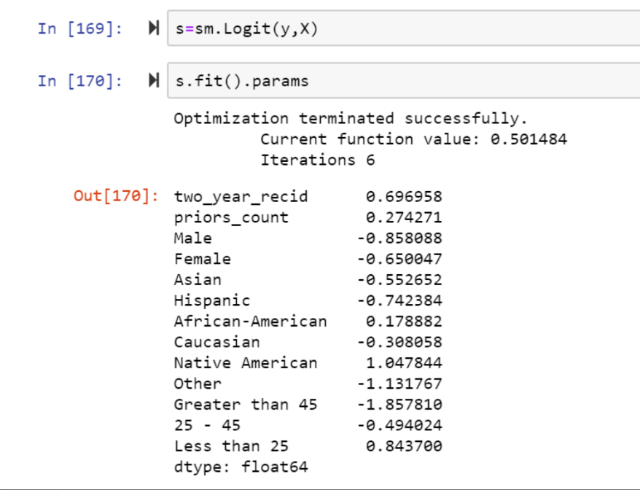At first we just followed the steps and replicated Pro-Publica’s Analysis. The results were as below and matched with ProPublica’s Data.

ProPublica used ‘two_year_recid’ , a variable derived from ‘is_recid’ variable (which denotes if any type of recidivism was done by the defendant i.e. violent or non-violent) to predict the risk score factor (Low or High) below are out 3 comments:

1. ProPublica modified risk factors from Low, Medium, and High to Low and High (by clubbing Medium with High) for a binary classification. This would increase the class distribution more towards High side and hence might be prone to inflated results
2. ProPublica should have used decile score for these predictions (same is mentioned by article no.2 mentioned above)
3. Two_year_recid variable is the actual information from the future years. It can be used to validate the result but ProPublica has used this in their analysis as an Independent variable which seems to be wrong and hence would bias the results

Additionally, we found there are some more features the root csv files which could be used in the analysis to add more details to it.

1. One such feature is ‘Charge_Degree’ which explains the actual charge degree for which a person is booked for rather than just classifying as ‘Felony’ or ‘Misdemeanor’
2. We clubbed all the juvenile crime records into one field by adding 0.5 weighted sum for Misdemeanor or other juvenile and counted entire entry for felony crimes
3. Calculated a feature named ‘Length_of_stay’ by subtracting the jain_in and jail_out dates

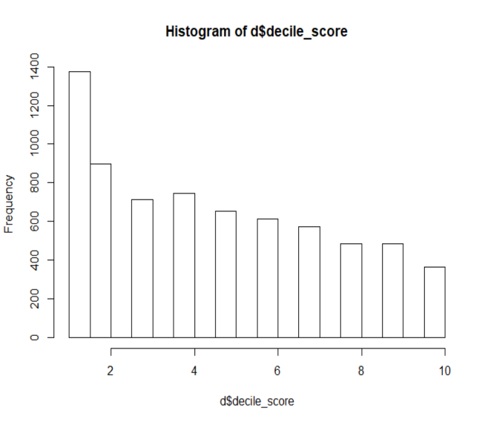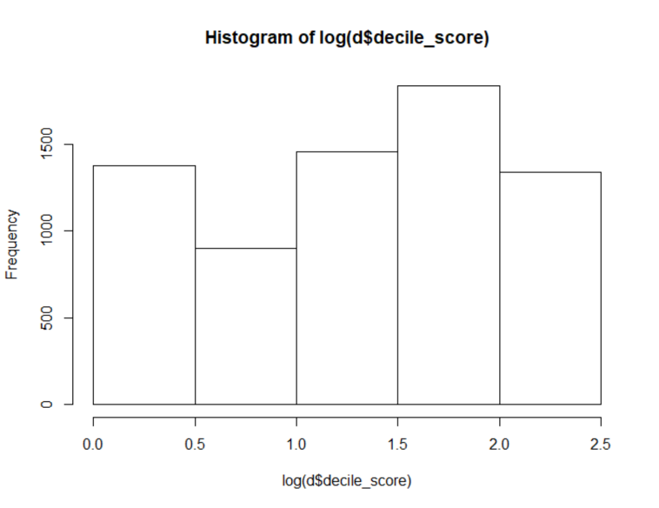We plotted the histogram of ‘decile_score’. The histogram is skewed towards right so we applied log transformation.

We ran a simple regression model using below variables to predict the decile score.

